**RESUME**

**Pappala Krishna Rao** 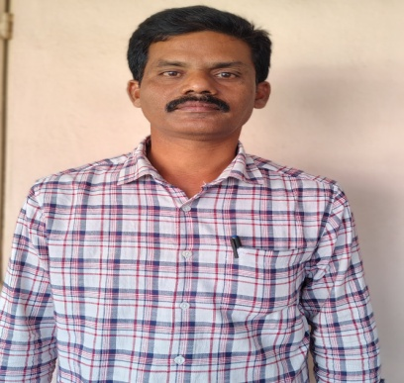

**Vullibhadra Village & Post**

**Garugubilli Mandalam**

**Pin: 535463**

**Vizianagaram District**

**Andhra Pradesh**

**Mobile no: 9704030171**

**Email: krishnarao.p1979@gmail.com**

**CAREER OBJECTIVE:**

**To work in an organization this provides me the opportunity to improve my skills and knowledge and to grow along with the organization objectives.**

**ACADEMIC QUALIFICATION:**

|  |  |  |  |  |
| --- | --- | --- | --- | --- |
| **COURSE** | **SCHOOL/ COLLEGE** | **BOARD / UNIVERSITY** | **YEAR OF PASSING** | **CGPA / %** |
| **B.Ed** | **YKM B.ed College** | **Board of teacher Education** | **2008** | **62%** |
| **MA Lit** | **SVU** | **SVU Tirupathi** | **2014** | **59%** |
| **Degree**  **BA** | **DBK Degree College Parvathipuram** | **Andhra University** | **2000** | **55%** |
| **Intermediate**  **(H.E.C)** | **Govt Jr College Parvathipuram** | **Board of Intermediate Education** | **1997** | **50%** |
| **SSC** | **DVMM High School Parvathipuram** | **Board of secondary Education** | **1995** | **55%** |

**COMPUTER SKILLS:**

**----**

**Personal Data:**

**Name : Pappala Krishna rao**

**Fathers Name : Gangunaidu**

**Date of birth : 01/07/1979**

**Sex : Male**

**Languages known : Telugu, English**

**Marital status : Married**

**Nationality : Indian**

**Religion : Hindu**

**Permanent Address : DOOR NO 1-121,**

**Gandhi Nagar Street, Vullibhadra**

**Garugubilli**

**Vizianagaram Dist**

**Andhra Pradesh**

**DECLARATION:**

**I am confident on my ability to working in a team and I hereby declare that the above furnished information is true to the best my knowledge.**

**Place :**

**Date : (Pappala Krishna RAO)**

**Signature**